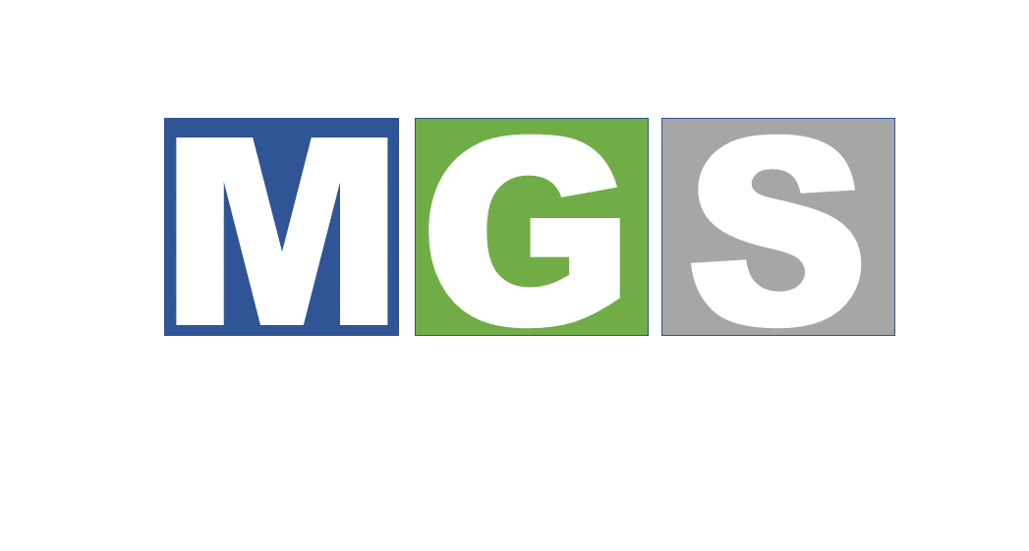

MGS FOR GENERAL TRADE & SUPPLIES
45 Kambiz Street – Administrative Floor, Business Hive, Opposite Shooting Club, Dokki, Cairo, Egypt
Tel: (02) 33365113 Mobile: 01200254201
Commercial Registration: 26993 Tax Card: 704-615-487

ABOUT US
MGS for General Trade & Supplies is an Egyptian company specialized in providing integrated supply solutions for private companies, institutions, and government entities.
Established in 2022 in Cairo, the company was founded to provide high-quality products and reliable supply services that meet the requirements of the Egyptian market in accordance with high standards of quality and commitment.
MGS offers a wide range of products and services covering industrial safety supplies, office supplies, cleaning products, and hospitality supplies, with a strong focus on timely delivery and competitive commercial solutions.
OUR VISION
To become a trusted and leading partner in general trading and supplies in Egypt by providing reliable services and integrated solutions that meet our clients’ requirements efficiently and professionally.
OUR MISSION
We aim to provide high-quality products and services that meet the diverse requirements of our clients, while maintaining integrity, timely execution, and long-term relationships built on trust and excellence.
OUR CORE VALUES
• Quality & Excellence
• Integrity & Transparency
• Commitment to Delivery
• Customer Satisfaction
• Continuous Improvement
• Professionalism

- INDUSTRIAL SAFETY SUPPLIES
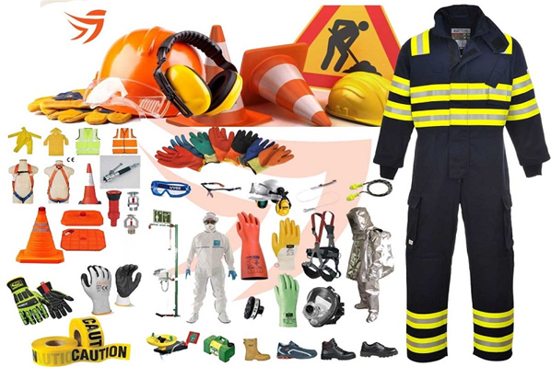

We provide a comprehensive range of industrial safety products required to support workplace protection and employee safety, including:

• Safety Helmets & Protective Headgear
• Safety Shoes
• High-Visibility Safety Vests
• Protective Gloves
• Safety Goggles & Protective Eyewear
• Masks & Personal Protective Equipment (PPE)
• Fire Extinguishers & Related Accessories
• Safety Signs & Warning Boards

2. OFFICE SUPPLIES

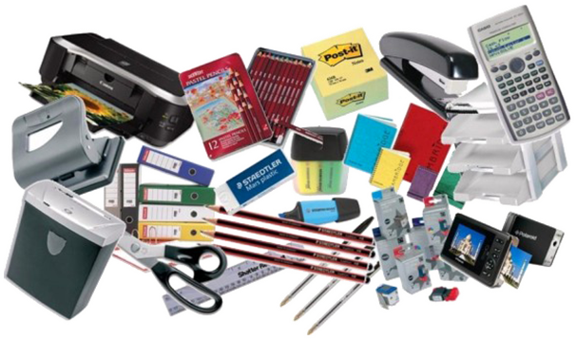

We provide a wide range of essential office supplies for companies and institutions, including:
• Paper & Printing Supplies
• Pens & Writing Instruments
• Files & Folders
• Ink Cartridges & Toners
• Organizational & Administrative Supplies
• Meeting & Presentation Supplies

3. HOSPITALITY & PANTRY SUPPLIES

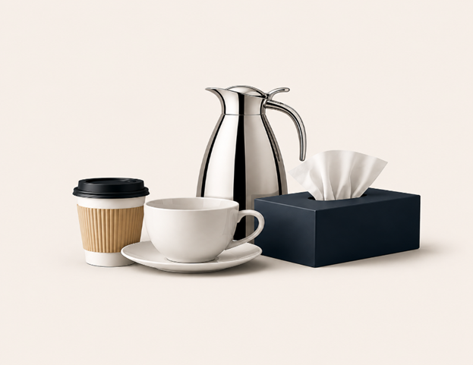

We provide a complete range of hospitality and pantry supplies for companies, offices, and institutions, including:
• Tea & Coffee
• Sugar & Coffee Creamers
• Bottled Water
• Paper & Plastic Cups
• Buffet & Pantry Supplies
• General Hospitality Products

WHY CHOOSE MGS?

GUARANTEED QUALITY

We focus on supplying products from reliable and trusted sources.

COMPETITIVE PRICING

We provide cost-effective supply solutions that meet our clients’ requirements.
TIMELY DELIVERY
- We are committed to processing orders efficiently and delivering them within the agreed timeframe.
- DEDICATED CUSTOMER SERVICE
- Our specialized team follows up on orders and provides continuous customer support.
- INTEGRATED SUPPLY SOLUTIONS
- We aim to meet our clients’ requirements through one reliable and professional supply partner.

TARGET CLIENTS
• Private Companies & Organizations
• Factories & Industrial Facilities
• Government Entities
• Hospitals & Medical Centers
• Schools & Universities
• Construction & Contracting Companies
• Administrative & Commercial Offices

OUR OBJECTIVES

• Expanding our client base across different sectors.
• Providing integrated supply services with high quality standards.
• Building long-term partnerships with clients and suppliers.
• Supporting the business environment by efficiently meeting organizational supply requirements.

CONTACT US
Tel: (02) 33365113 Mobile: 010 25420177
45 Kambiz Street – Administrative Floor, Business Hive, Opposite Shooting Club, Dokki, Cairo, Egypt

